Chinese Arts Quarterly (CAQ)
Format and Documentation Style

All papers submitted to Chinese Arts Quarterly (CAQ) should be printed in the MLA (Modern Language Association) format and follow the MLA documentation style. The MLA format and documentation style are used in scholarship throughout the arts and humanities, including cultural studies, fine arts studies, history studies, literary and artistic criticism, media studies, modern languages and literatures, musicology, and related disciplines. MLA documentation style offers a uniform set of rules and conventions to govern the presentation of tables, graphs, notes, appendixes as well as quotation and bibliography in academic articles and books.
The MLA documentation style is based on MLA Style Manual and Guide to Scholarly Publishing and MLA Handbooks for Writers of Research Papers, both of which were preceded by a slim booklet titled the MLA Style Sheet, first published in 1951 and revised in 1970. Though the Style Sheet was allowed to go out of print after the commercial success of the Handbook, creating the need for the Manual as a companion to the Handbook, the gist of this set of academic style guide adopted by the art and humanity journals still keeps to the Style Sheet. This is why CAQ insists on using MLA format after the MLA Style Manual went out of print in 2016—the purpose of any additional publications is always to “address the professional needs of scholars.”

The Format of the Paper

- Electronic Submission
Electronic submission is required for all papers to be published in the journal. The paper must be a Microsoft Word file, with Times New Roman as the formal typeface and small four the normal font.

- Page Size and Margins
Choose the A4 paper in the Page Layout of the Microsoft Word program. There select the “General” from the Margins (top and down: 2.54cm; left and right: 3.18cm).

- Spacing
The paper must be single-spaced throughout, including quotations, notes, and list of works cited. However, before the title, subtitle, and heading and after the title and heading (not the subtitle) must leave one-line space out.

- Heading and Title
The paper does not need a title page. Instead, begin the paper title a line (small-four-font space, hereafter the same) below the top margin of the first page and present it in the normal three font, keeping it a centered, uppercase and lowercase heading in boldface. The name(s) of the author(s) should be provided below the paper title (the normal four font, centered, and capitalized), and one line should be left out both before and after the name(s). The title of every part and the subtitle of every section in the paper should begin with the left margin, all presented as uppercase and lowercase headings in boldface. The title should be in the normal four font, and a line be left out both before and after it. The subtitle should be in the small four font, and a line be left out only before it.
The rules for capitalizing titles are strict. In both titles and subtitles, capitalize the first words, the last words, and all principal words, including that follow hyphens in compound terms. Therefore, capitalize the following parts of speech:
·Nouns (e.g. symphony as in Beethoven Symphony No. 7)
·Pronouns (e.g. our as in In Our Town; that, it, and you as in The Portrait It Paints of You)
·Verbs (e.g. sell as in Chinese Arts Sell into the World Market)
·Adjectives (e.g. surviving as in Companionship between the Surviving Painters)
·Adverbs (e.g. away and across as in Away or Across: Companionship of the Surviving Ming Painters in Jiangnan Area during Early Qing Dynasty)
·Subordinating conjunctions (e.g. if as in One If by Mendelssohn)
Do not capitalize the following parts of speech when they fall in the middle of a title:
·Articles (e.g. a as in What Is a Sonata; the as in The Old Man and the Sea)
·Prepositions (e.g. in as in Beethoven Symphony No. 9 in D Minor)
·Coordinating conjunctions (e.g. or as in Liszt or Chopin)
·The to in infinitives (as in How to Cite Resources Using MLA Format)

- Author’s Name and Brief Personal Data
The author’s name should be presented fully and accurately below the Paper’s title. Do not change Martin Luther King, Jr. to Martin Luther King, for example, or drop the hyphen in Victoria M. Sackville-West. The Asian authors—e.g. Chinese, Korean, and Japanese authors—must present their names in the Romanizing spelling, but they may simply follow their natural way in doing so, that is, the surname preceding the given name:
·Chinese: Liu Zhongxing; Cai Min
·Korean: Kim Youngmin; Park Jin-young
·Japanese: Hayao Miyazaki; Masanori Takahashi
Below the author’s name, the abstract (the word is to be presented as a subtitle) of the paper must be given, beginning at the left margin. Still below the abstract shall be the “keywords” (also as a subtitle), again beginning at the left margin.
Brief personal data about the author must be given after the key words, as is the primary information about the author (name, address, research institute, email, etc.)

- Tables and Illustrations
Place tables and illustrations as close as possible to the parts of the text to which they relate. A table is usually labeled “Table,” given an Arabic number, and captioned. Type both table and caption flush as a subtitle. Give the source of the table and any notes immediately below the table (to avoid confusion between notes to the table and those to the text, which are to be presented as footnotes).
Any other type of illustrative visual material—for example, a photograph, map, line drawing, graph, or chart—should be labeled “Figure” (usually abbreviated “Fig.”), assigned an Arabic numeral, and given a title or caption. If the paper has many illustrations, the author is suggested to be familiar with the computer drafting software, which automatically numbers tables and illustrations, sets them appropriately into the text, and generates a listing of all tables and illustrations created for the paper.
Musical illustrations are labeled “Example” (usually abbreviated “Ex.”), assigned an Arabic numeral, and given a title or caption. A label and title or caption ordinarily appear directly below the example and shall be accepted as a subtitle (boldface unnecessary).
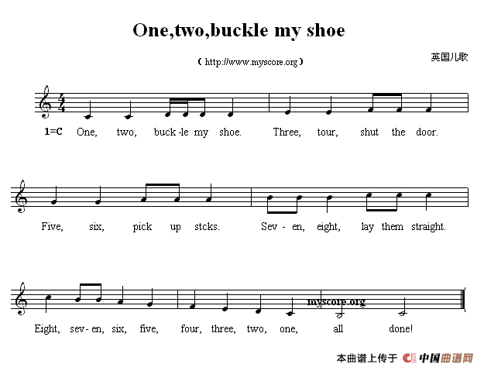

Ex. 1. A Musical Example in a Paper

- Notes
When notes to the text become necessary, they should be provided as “footnotes” in the Microsoft Word file. They shall be assigned an Arabic numeral, presented in small five font, single-spaced, and Times New Roman typeface.

